Unarchive a Patient in Pinnacle

**Note:**The Pinnacle username and password are both [redacted]. You may need to type in the password and press enter, twice.

1. From Launch Pad, left-click the *Restore* icon.

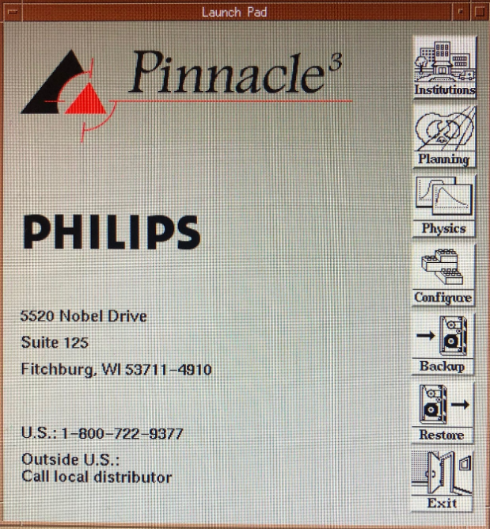

The *Restore* window should appear.

1. Navigate to the *Restore from Index* tab.
2. Left-click the arrow beside the institution name that contains the patient’s files. The institutions roughly correspond to Pinnacle versions. Use the binders in the cabinet above [redacted]’s diploma to determine which institution contains the patient’s files.
3. Left-click the arrow beside the *Patients* subfolder. Left-click the patient’s name.

Add to List

1. Left-click .
2. Left-click .

Restore

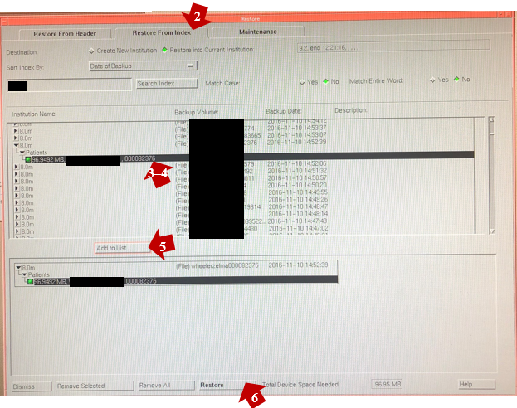

The patient is restored to the institution from which it was archived.